AS3959 FMC

Predicting MC from Tair and RH based on dry eucalyptus litter,

(Viney 1992)

For RH=25% and T=39 0C (102 0F) , MC=3.84%

Is this MC being valid? Relationship between RH and T?

**Psychrometric chart**

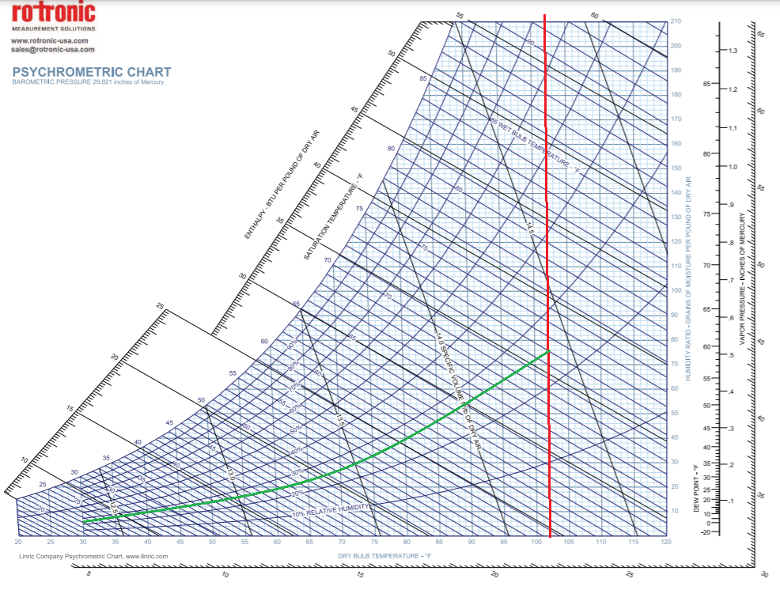

Where P= 304 g (the amount of moisture needs to saturate)

**From NSW rural fire service**

(https://nswrfs.atlassian.net/wiki/spaces/TECHNICAL/pages/44502505/Fuel+Moisture+Content+Description)

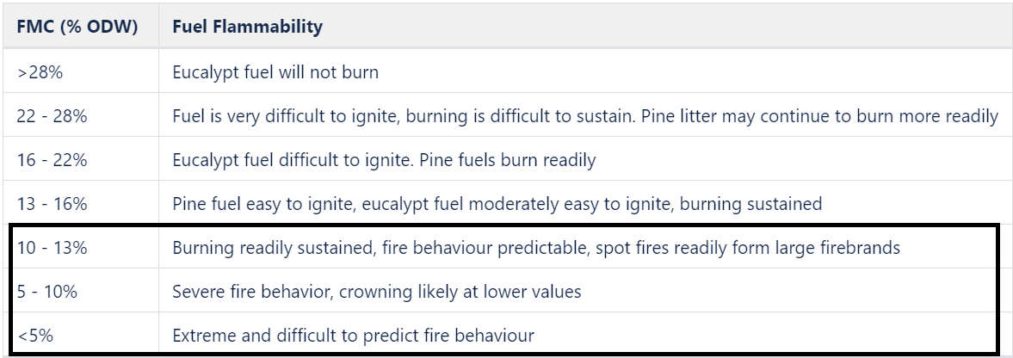

Method 1:

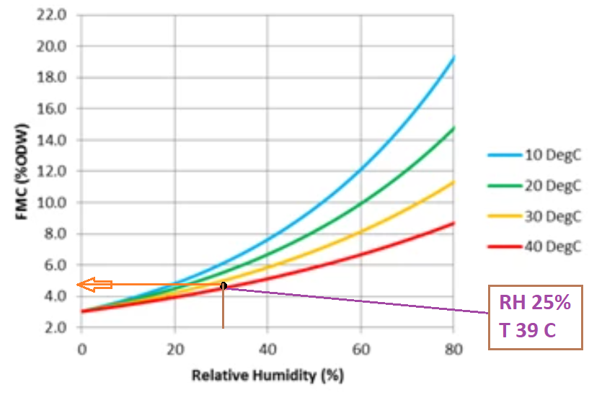

When RH =25% and T=39 0C, the FMC is around 5%.

Our value for AS3959 is 3.84%.

Method 2:

|  |  |  |  |
| --- | --- | --- | --- |
| Forest | FDI | ROS(km/h/) | Wind speed (km/h) |
| 50 | 1.49 | 40 |
| 80 | 2.38 | 60 |
| 100 | 3.01 | 70 |

